**Implementation** **File Server Connection**

**2.1. Prerequisite:**

1.File Server must be shared.

## **2.2. File Server Connection:**

## **How to use of File Server Connection:**

**How to create File Server PowerShell script "Connection_FileServer.ps1”**

1. Open PowerShell IDE and paste below content (Code mention in step 1 only) into PowerShell.

Function Write-Log

{

[CmdletBinding()]

Param(

[Parameter(Mandatory=$False)]

[ValidateSet("INFO","WARN","ERROR","FATAL","DEBUG")]

[String]

$Level = "INFO",

[Parameter(Mandatory=$True)]

[string]

$Message,

[Parameter(Mandatory=$False)]

[string]

$logfile

)

$content = "[$Stamp] [$Level] $Message"

if($logfile)

{

Add-Content $logfile -Value $content

}

else

{

Write-Output $content

}

}

function Get-CurrentLineNumber

{

$MyInvocation.ScriptLineNumber

}

$ScriptDirectory = "{{cache_dir}}"

$InstallerLogFileName="$ScriptDirectory\Connection_FileServer.txt"

Test-Path \\{{file_server_ip}}\{{file_server_shared_folder}} >>{{cache_dir}}\FileServer.txt

$Val = Get-Content {{cache_dir}}\FileServer.txt

$a = $true

try

{

if($Val -eq $a)

{

$Val2 = Get-Childitem –Path \\{{file_server_ip}}\{{file_server_shared_folder}}

Write-Log "INFO" "[$(Get-CurrentLineNumber)] $Val2 'File Server connection made successfully and file read sucessfully.' "$InstallerLogFileName""

}

else

{

throw Exception

}

}

catch

{

Write-Log "INFO" "[$(Get-CurrentLineNumber)] 'Exception Occur, Can not check file server connection.' "$InstallerLogFileName""

}

2. Save the script with name Connection_FileServer.ps1

**Check File Server Connection using manual steps**

1. Login to TS server.

2. Open File Explore

3. Click on Search bar.

4. Enter \\< File Server IP >

5. You will successfully login into File server.

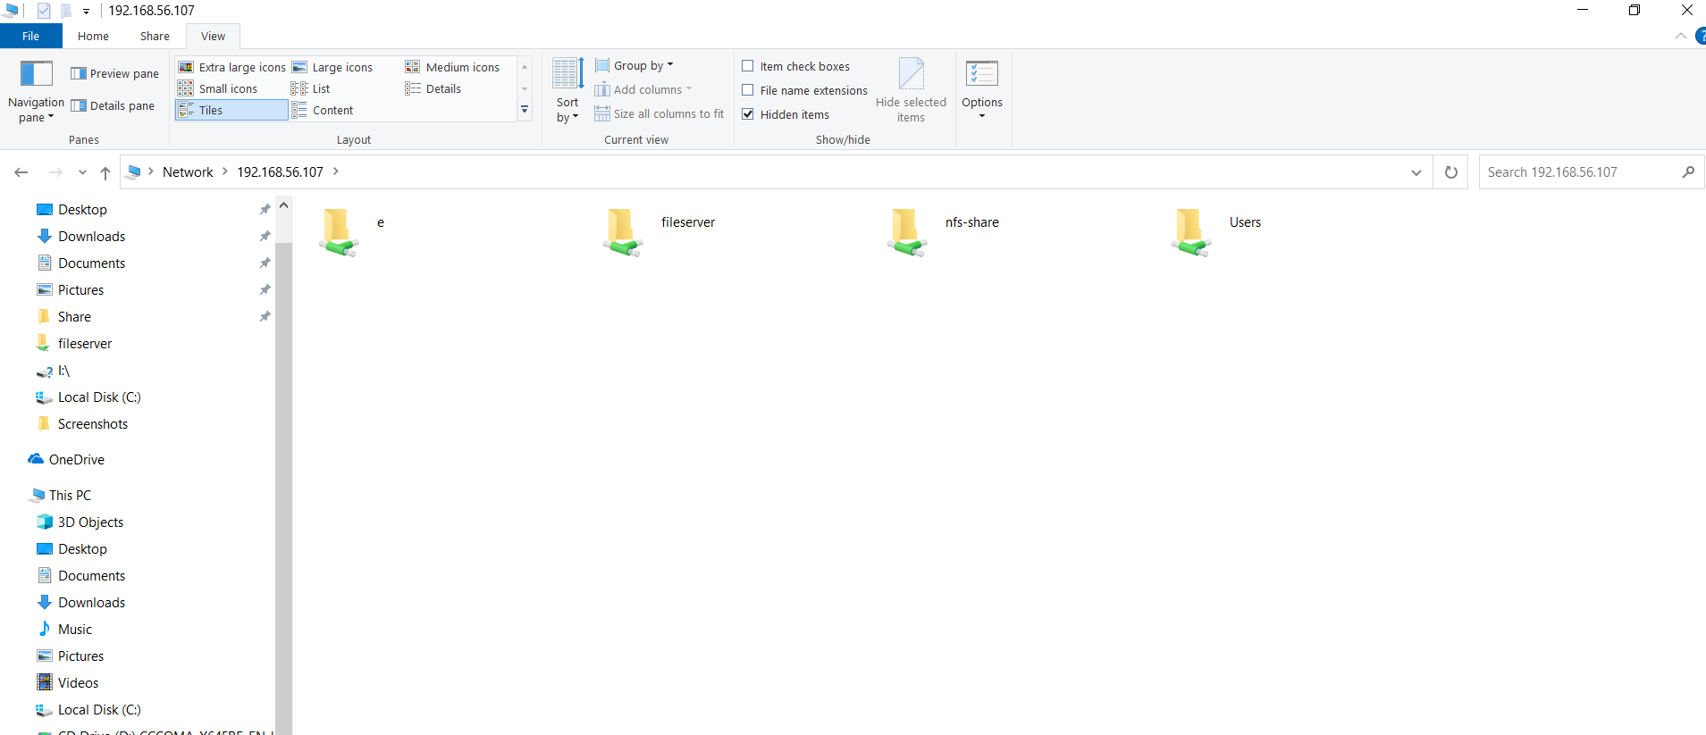

Fig.2.1. Login window for File Server

## **Evidence:**

Local Execution with Evidence.

Below command executed on TS server

**Command:**

C:\Connection_FileServer.ps1

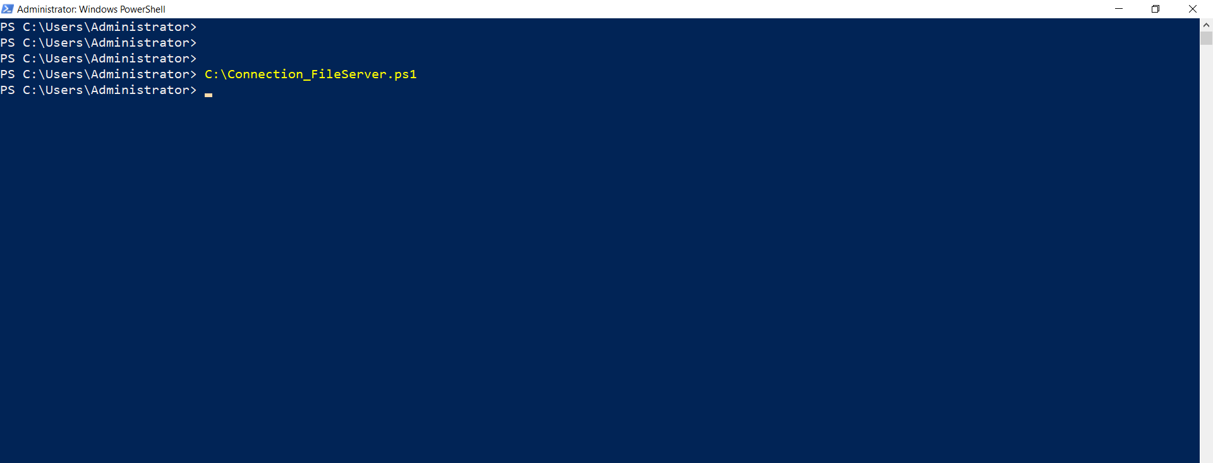

Fig.2.2. Executed Command on TS server

Remote Execution with Evidence

Below command executed on TS server

**Command:**

python

import winrm

s = winrm.Session('192.168.56.117', auth=('Administrator','abc@123'))

r = r = s.run_ps('C:\\Connection_FileServer.ps1')

r.status_code

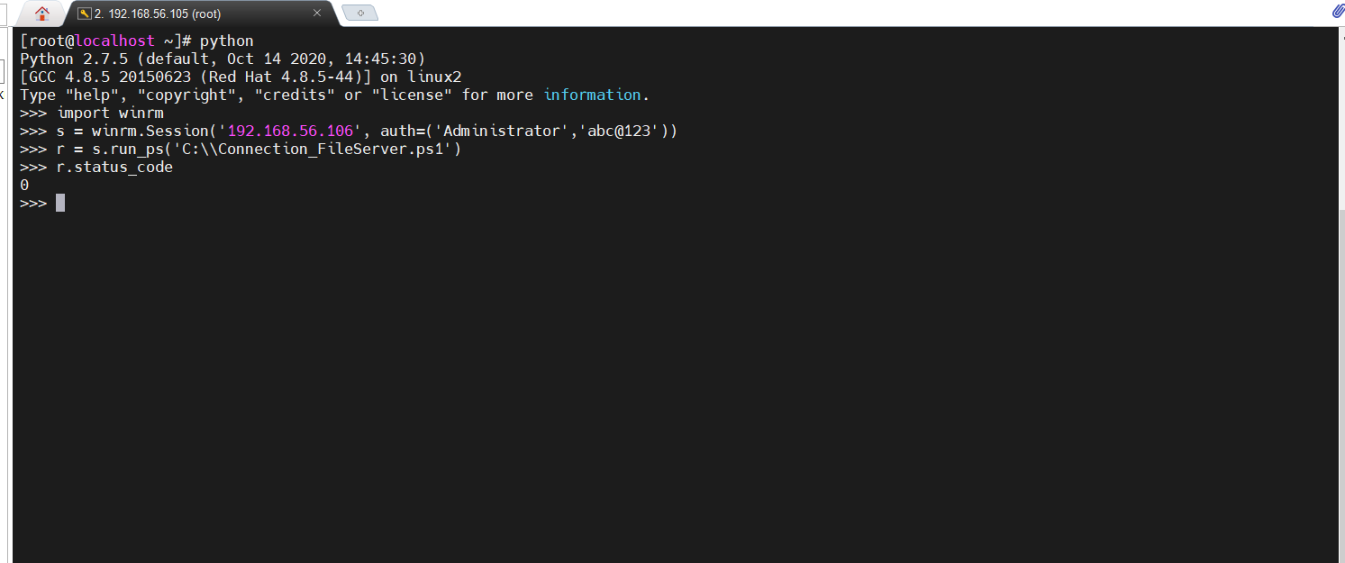

Fig.2.3. Remote Execution on TS Server Successful status evidence

## **Verification:**

1. Login to the TS server.

2. Go into path <cache_dir>.

3. Fileserver.log.txt file must be there.

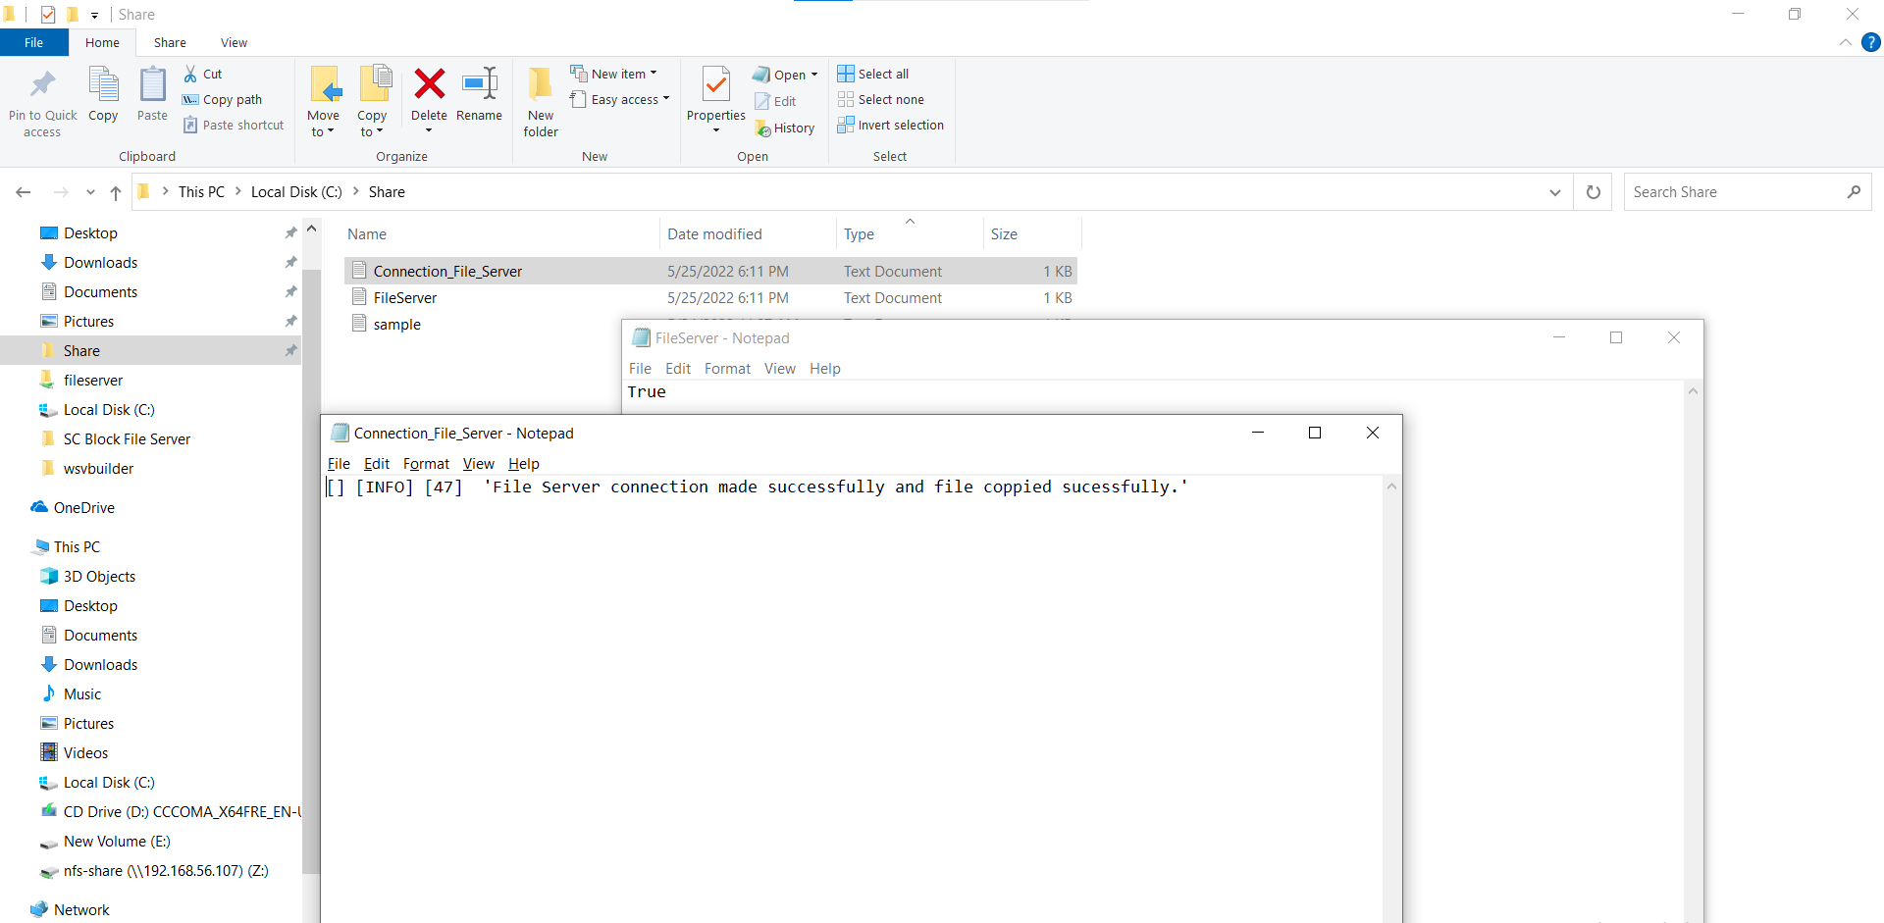

Fig.2.4. Verification of File server connection.